Data Modeling Reverse Engineering with Azure SQL AdventureWorksLT

Main model

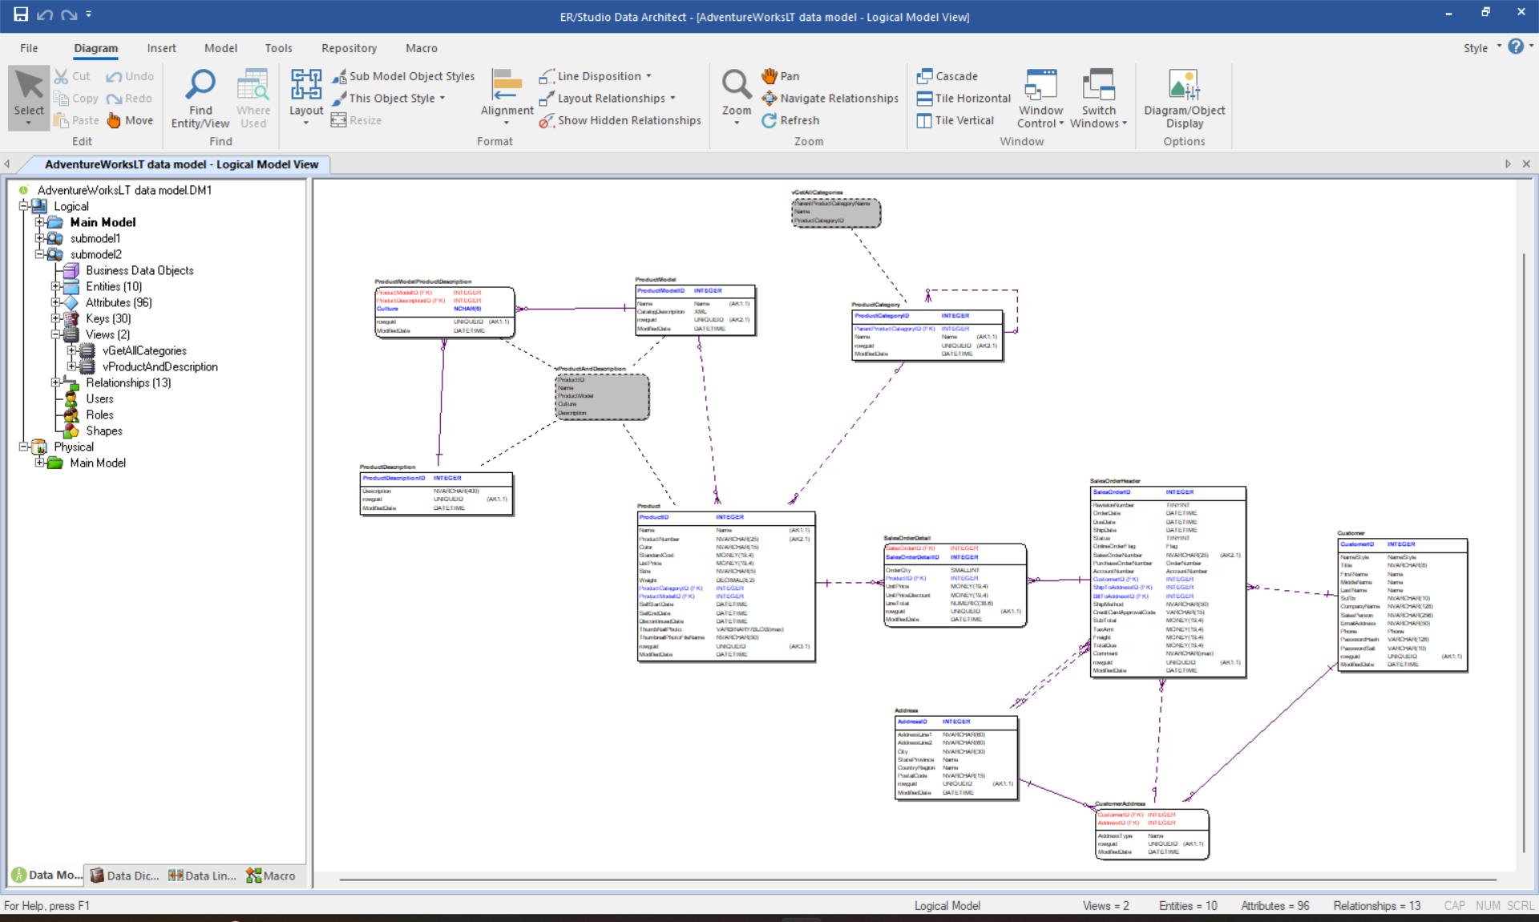

Submodel 1

Submodel 2

